
ISTANBUL TECHNICAL
0
1
UNIVERSITY

COMPUTER ENGINEERING
COMPUTER ORGANIZATION

PROJECT # 3
SIMPLE COMPUTER WITH
HARDWIRED CONTROL UNIT
REPORT

STUDENT NO NAME SURNAME
040100113 MUSTAFA UÇAR
040100117 TUĞRUL YATAĞAN
040100124 EMRE GÖKREM
040100054 HÜSEYİN ERDOĞAN

DUE DATE: 01.05.2013

INSTRUCTION SET FOR SIMPLE COMPUTER

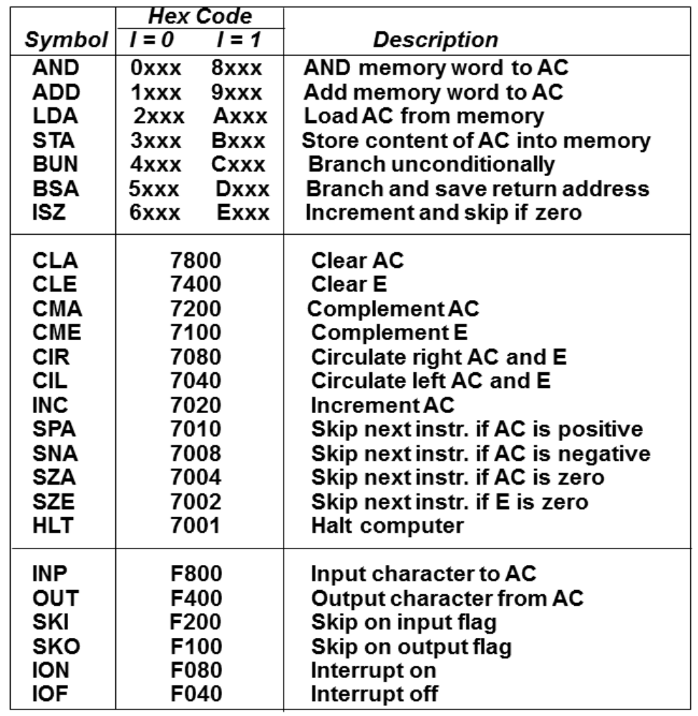

There are only two external input for simple computer, these are FGI and FGO input-output flags for the rest simple computer needs machine codes on its RAM for work.

